<https://www.w3schools.com/php/showphp.php?filename=demo_ajax_mysql>

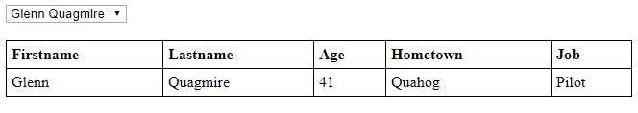

<!DOCTYPE html>  
<html>  
<head>  
<script>  
function showUser(str) {

  if (str=="") {  
    document.getElementById("txtHint").innerHTML="";  
    return;  
  }

  var xmlhttp=new XMLHttpRequest();  
  xmlhttp.onreadystatechange=function() {  
    if (this.readyState==4 && this.status==200) {  
      document.getElementById("txtHint").innerHTML=this.responseText;  
    }  
  }  
  xmlhttp.open("GET","getuser.php?q="+str,true);  
  xmlhttp.send();  
}  
</script>  
</head>  
<body>  
  
<form>  
 <select name="users" onchange="showUser(this.value)">  
 <option value="">Select a person:</option>  
 <option value="1">Peter Griffin</option>  
 <option value="2">Lois Griffin</option>  
 <option value="3">Joseph Swanson</option>  
 <option value="4">Glenn Quagmire</option>  
 </select>  
</form>  
<br>

<div id="txtHint"><b>Person info will be listed here.</b></div>  
  
</body>  
</html>

getuser.php

<!DOCTYPE html>  
<html>  
<head>  
<style>  
table {  
  width: 100%;  
  border-collapse: collapse;  
}  
  
table, td, th {  
  border: 1px solid black;  
  padding: 5px;  
}  
  
th {text-align: left;}  
</style>  
</head>  
<body>  
  
<?php  
$q = intval($_GET['q']);  
  
$con = mysqli_connect('localhost','peter','abc123','my_db');  
if (!$con) {  
  die('Could not connect: ' . mysqli_error($con));  
}  
  
mysqli_select_db($con,"ajax_demo");  
$sql="SELECT * FROM user WHERE id = '".$q."'";  
$result = mysqli_query($con,$sql);  
  
echo "<table>  
<tr>  
<th>Firstname</th>  
<th>Lastname</th>  
<th>Age</th>  
<th>Hometown</th>  
<th>Job</th>  
</tr>";

while($row = mysqli_fetch_array($result)) {  
  echo "<tr>";  
  echo "<td>" . $row['FirstName'] . "</td>";  
  echo "<td>" . $row['LastName'] . "</td>";  
  echo "<td>" . $row['Age'] . "</td>";  
  echo "<td>" . $row['Hometown'] . "</td>";  
  echo "<td>" . $row['Job'] . "</td>";  
  echo "</tr>";  
}  
echo "</table>";  
mysqli_close($con);  
?>  
</body>  
</html>